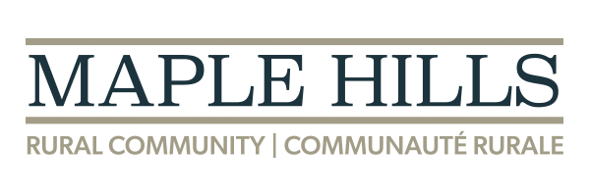

Public NOTICE OF BY-LAW NO. 21-WAP-069-MH-03 APPROVAL
Please be advised the Rural Community of Maple Hills Zoning By-law Amendment No. 21-WAP-069-MH-03, which rezones PID 70550934 from Residential (R) Rural Area (RA) was approved by Council on February 18th, 2025 and registered in the Westmorland Registry Office on February 26th, 2025 as Registry Number 45830321.

